SOFTWARE DOCUMENTATION

PERSONAL PORTFOLIO WEBSITE



Prepared By
Franklin Okeke
Full Stack Developer | AI Engineer | Electrical Engineer
Document Version: 1.0
Documentation Type: Software Design & Technical Documentation
Date: July 2026
This document provides a comprehensive technical and functional documentation of the Personal Portfolio Website, including its architecture, user interface, technologies, workflows, and implementation details.

Table of Contents

· Cover Page
· Table of Contents
· Document Control & Revision History
1.0 Introduction
2.0 Project Overview
3.0 Purpose of the Documentation
4.0 Objectives
5.0 Technology Stack
6.0 System Architecture
7.0 Portfolio Website Structure
8.0 Detailed Section Documentation
· 8.1 Navigation Bar
· 8.2 Hero Section
· 8.3 Services
· 8.4 Skills & Technical Competence
· 8.5 AI Projects
· 8.6 Full Stack Projects
· 8.7 Education & Professional Experience
· 8.8 Certifications & Continuous Learning
· 8.9 Achievements & Recognition
· 8.10 Contact
· 8.11-Footer
9.0 Functional Requirements
10.0 Non-Functional Requirements
11.0 Responsive Design
12.0 Navigation Workflow
13.0 Testing & Validation
14.0 Deployment
15.0 Maintenance
16.0 Future Enhancements
17.0 Conclusion
· Appendix
Note: Page numbers will be updated automatically after all sections are completed.

Document Control & Revision History

3.1 Document Control
Item | Details
Document Title | Software Documentation – Personal Portfolio Website
Project Name | Franklin Okeke Portfolio Website
Document Version | Version 1.0
Author | Franklin Okeke
Prepared By | Franklin Okeke
Document Type | Software Design & Technical Documentation
Status | Draft
Confidentiality | Internal / Academic / Portfolio
Date | July 2026
Approval | Pending Final Review

3.2 Revision History
Version | Date | Author | Description of Changes | Status
1.0 | July 2026 | Franklin Okeke | Initial creation of software documentation. | Draft

3.3 Purpose of Document Control
This section records document ownership, version information, approval status, and all future revisions. It ensures that every modification made to the software documentation is traceable, supports collaboration, maintains document integrity, and provides a reliable reference throughout the lifecycle of the portfolio website.

1.0 Introduction

1.1 Background
The Personal Portfolio Website is a modern, responsive web application developed to present the professional profile, technical expertise, projects, achievements, and career journey of Franklin Okeke. The website serves as a digital portfolio for recruiters, employers, clients, collaborators, and academic assessors by providing a centralized platform for showcasing software engineering, artificial intelligence, and electrical engineering competencies.

1.2 Purpose of the Website
The portfolio was developed to establish a professional online presence, demonstrate practical software development skills, showcase completed AI and Full Stack projects, and provide visitors with an easy way to learn about the developer and make contact.

1.3 Scope
This documentation covers the design, structure, technologies, functional components, user interface, navigation, responsiveness, deployment considerations, and maintenance of the portfolio website. It documents both the software implementation and the user-facing features.

1.4 Intended Audience
This document is intended for software developers, project supervisors, lecturers, recruiters, employers, clients, and technical reviewers who require a detailed understanding of the portfolio website.

1.5 Document Organization
The remaining chapters describe the project overview, system overview, architecture, detailed documentation of every website section, functional and non-functional requirements, testing, deployment, maintenance, and future enhancements.

1.6 Objectives of this Documentation
· Provide a complete technical reference for the portfolio website.
· Explain the architecture, technologies, and design decisions.
· Document each user interface section with screenshots in later chapters.
· Support future maintenance, upgrades, and knowledge transfer.
· Serve as professional and academic software documentation.

2.0 Project Overview
This chapter provides a comprehensive overview of the Personal Portfolio Website, including its purpose, scope, technical specifications, users, and major features.
Item | Description
Project Name | Franklin Okeke Personal Portfolio Website
Application Type | Responsive Single-Page Portfolio Website
Developer | Franklin Okeke
Version | 1.0
Website URL | https://franklin-okeke.github.io/AI_Portfolio_Project
Target Users | Recruiters, employers, clients, collaborators, academic assessors
Technology Stack | HTML5, Tailwind CSS, Font Awesome
Responsive | Desktop, Tablet and Mobile
Number of Web Pages | 1 (Single Page Application)
Major Sections | Navigation, Hero, Services, Skills, AI Projects, FullStack Projects, Education, Certifications, Achievements, Contact, Footer

2.1 Project Description
The portfolio serves as a professional digital identity showcasing technical skills, software projects, AI solutions, education, certifications, and career achievements in a modern user interface.

2.2 Project Objectives
Present professional experience, demonstrate practical development skills, improve employability, and provide an accessible platform for communication.

2.3 Key Features
Responsive design, dark theme, interactive project showcase, AI portfolio, education and certification sections, achievements, and contact form.

3.0 System Overview
The System Overview provides a high-level visual and functional description of the Personal Portfolio Website. It introduces the homepage, explains the overall user interface, identifies the major sections of the application, and describes how visitors navigate through the website.

3.1 Portfolio Homepage Overview
The homepage serves as the primary entry point into the portfolio. It presents a modern dark-themed interface with clear navigation, professional branding, project showcases, and responsive layouts. Visitors can quickly access information about the developer, technical skills, AI projects, Full Stack projects, education, certifications, achievements, and contact information.
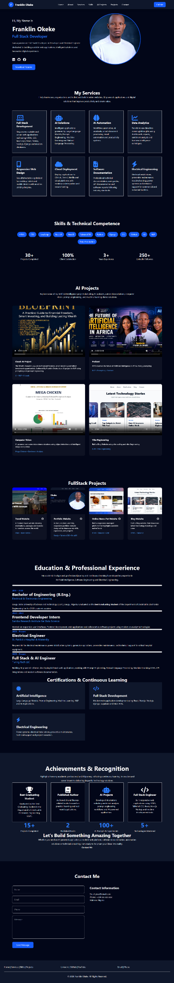
Figure 3.1: Complete Homepage of the Personal Portfolio Website

3.2 Major Website Sections
Section | Purpose
Navigation Bar | Provides quick navigation to all major sections.
Hero Section | Introduces the developer and highlights key expertise.
Services | Presents professional services offered.
Skills | Displays technical competencies and technologies.
AI Projects | Showcases Artificial Intelligence projects.
Full Stack Projects | Highlights software engineering projects.
Education & Experience | Summarizes academic and professional background.
Certifications | Lists certifications and continuous learning.
Achievements | Highlights awards and milestones.
Contact | Provides communication channels and contact form.
Footer | Contains copyright and quick navigation links.

3.3 Website Navigation Flow
Users begin at the Navigation Bar and Hero Section, then scroll through Services, Skills, AI Projects, Full Stack Projects, Education & Experience, Certifications, Achievements, Contact, and finally the Footer. This linear navigation model ensures a smooth user experience on desktop, tablet, and mobile devices.

3.4 Key Functional Components
· Responsive user interface for multiple screen sizes.
· Interactive project showcase with images and videos.
· Professional branding and personal profile presentation.
· Technology and skills visualization.
· Integrated contact section for prospective employers and clients.

3.5 Summary
The System Overview establishes a comprehensive understanding of the portfolio website before examining each individual component in detail. Subsequent chapters document every section separately with dedicated screenshots and technical explanations.

4.0 User Interface Documentation

4.1 Navigation Bar

4.1.1 Overview
The navigation bar is the primary navigation interface of the portfolio website, providing branding and access to all major sections.
Figure 4.1: Navigation Bar of the Personal Portfolio Website

4.1.2 Components
Component | Description | Purpose
Logo | Circular blue 'F' | Brand identity
Developer Name | Franklin Okeke | Professional branding
Navigation Links | Home, About, Services, Skills, AI Projects, Projects, Contact | Navigate to sections
Call Me Button | CTA button | Direct contact

4.1.3 Functional Behavior
Supports smooth navigation across the single-page website and provides immediate access to important sections.

4.1.4 Technical Implementation
Built using semantic HTML5 and Tailwind CSS Flexbox utilities for alignment, spacing, typography, and responsiveness.

4.1.5 Responsive Behavior
Optimized for desktop and adaptable for mobile navigation using a collapsible menu in future versions.

4.1.6 Design Considerations
Dark theme, high contrast, consistent blue accent color, and balanced spacing improve usability and visual appeal.

4.1.7 Future Enhancements
Sticky navigation, active link highlighting, ARIA support, keyboard navigation, and animated mobile menu.

4.1.8 Summary
The navigation bar serves as the central navigation mechanism and establishes a strong first impression through clear branding and intuitive organization.

4.2 Hero Section

4.2.1 Overview
The Hero Section is the primary introduction to the portfolio website. It presents the developer's identity, profession, profile photograph, social media links, and a call-to-action to download the résumé.
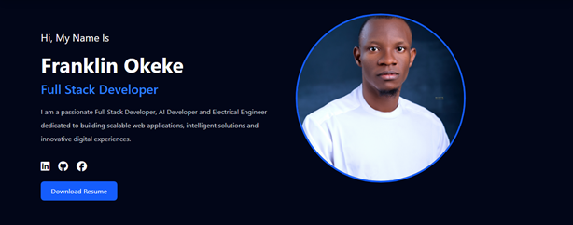
Figure 4.2: Hero Section of the Personal Portfolio Website

4.2.2 Components
Component | Description | Purpose
Greeting | Hi, My Name Is | Welcome message
Developer Name | Franklin Okeke | Professional branding
Professional Title | Full Stack Developer | Career identity
Biography | Short professional summary | Introduce expertise
Profile Image | Professional portrait | Build trust
Social Icons | LinkedIn, GitHub, Facebook | Networking
Resume Button | Download Resume | Call-to-action

4.2.3 Functional Behavior
Introduces the developer, encourages profile exploration, and provides direct access to professional platforms and the résumé.

4.2.4 Technical Implementation
Built with HTML5 and Tailwind CSS using a responsive Flexbox layout with utility classes for spacing, typography, and alignment.

4.2.5 Responsive Behavior
Displays as two columns on desktop and a stacked layout on smaller devices for improved usability.

4.2.6 UI/UX Considerations
Dark theme, blue accents, consistent typography, and balanced whitespace create a modern professional appearance.

4.2.7 Future Enhancements
Typing animation, animated CTA, profile hover effects, and additional contact shortcuts.

4.2.8 Summary
The Hero Section establishes a strong first impression and effectively communicates the developer's professional identity.

4.3 Services Section
This revised section documents the complete Services area of the portfolio website, including all eight service cards presented in a responsive grid.
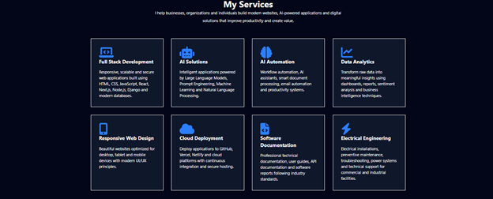
Figure 4.3: Complete Services Section

4.3.1 Overview
The Services section communicates the developer's core competencies through eight service cards. Each card combines an icon, title and concise description to help visitors quickly understand the available professional services.

4.3.2 Service Catalogue
Service | Description | Primary Value
Full Stack Development | Modern web applications. | Business software
AI Solutions | LLMs, Prompt Engineering, ML, NLP. | AI-powered systems
AI Automation | Workflow and document automation. | Productivity
Data Analytics | Dashboards and reporting. | Business insights
Responsive Web Design | Responsive UI/UX. | Cross-device access
Cloud Deployment | GitHub, Vercel, Netlify, cloud hosting. | Reliable deployment
Software Documentation | Technical reports, API guides. | Maintainability
Electrical Engineering | Power systems and maintenance. | Engineering support

4.3.3 Card Layout
The services are arranged in a responsive four-column grid on large displays and collapse gracefully on smaller screens using Tailwind CSS grid utilities.

4.3.4 Visual Design
A dark theme, blue icons, white headings and consistent card spacing create a clean and professional appearance. Equal card sizing improves visual balance.

4.3.5 Functional Behavior
Although informational, each card highlights a specialized capability and encourages visitors to continue exploring the portfolio and initiate contact.

4.3.6 Technical Implementation
Developed using semantic HTML5 and Tailwind CSS. Reusable card components, utility classes, responsive grids and hover-ready styling simplify maintenance.

4.3.7 Responsive Behavior
Desktop displays four cards per row, tablets reduce the number of columns, and mobile devices present a single-column layout for readability.

4.3.8 Accessibility
High color contrast, readable typography, consistent spacing and recognizable icons improve accessibility and usability.

4.3.9 Future Enhancements
Interactive hover animations, links to case studies, service detail pages, animated icons, and filtering by category.

4.3.10 Summary
The complete Services section effectively presents the breadth of the developer's expertise while maintaining a consistent, scalable and professional interface.

4.4 Skills & Technical Competence
This chapter documents the Skills & Technical Competence section of the portfolio website.
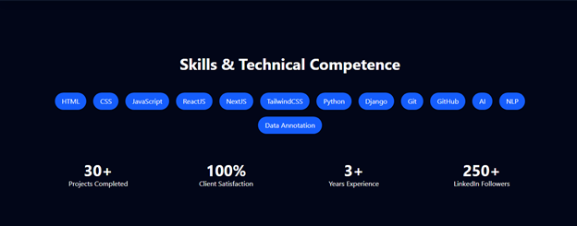
Figure 4.4: Skills & Technical Competence Section

4.4.1 Overview
This section showcases the developer’s technical stack and measurable professional achievements.

4.4.2 Skills Catalogue
Technologies include HTML, CSS, JavaScript, ReactJS, NextJS, Tailwind CSS, Python, Django, Git, GitHub, AI, NLP and Data Annotation.

4.4.3 Professional Statistics
The dashboard highlights 30+ Projects Completed, 100% Client Satisfaction, 3+ Years Experience and 250+ LinkedIn Followers.

4.4.4 Design & Layout
Responsive pill-shaped badges and evenly spaced statistics create a clean and modern interface.

4.4.5 Technical Implementation
Built with HTML5 and Tailwind CSS using flexbox, responsive utilities and reusable components.

4.4.6 Responsive Behavior
Skill badges wrap naturally while statistics adapt for tablet and mobile screens.

4.4.7 Accessibility & UX
High contrast, consistent spacing and readable typography improve usability.

4.4.8 Future Enhancements
Animated counters, proficiency bars, category filters and tooltips.

4.4.9 Summary
This section communicates the breadth of technical expertise in a concise visual format.

4.5 AI Projects Section
This chapter documents the AI Projects section of the portfolio website. The section showcases four representative Artificial Intelligence projects demonstrating expertise in AI, NLP, prompt engineering, computer vision and AI-assisted software development.
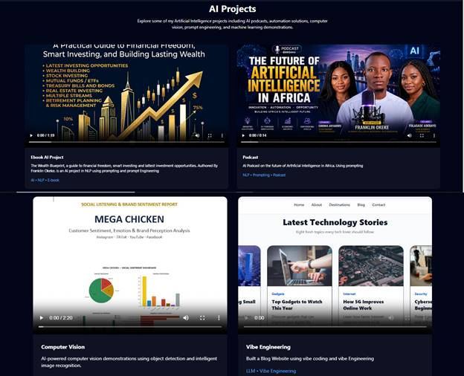
Figure 4.5: Complete AI Projects Section

4.5.1 Overview
The AI Projects section presents four featured projects arranged in a responsive two-column grid. Each project includes a preview video, title, short description and technology tags.

4.5.2 Section Layout
The section uses responsive project cards with embedded videos. Cards maintain equal dimensions and spacing for visual consistency.

4.5.3 Project 1 – The Wealth Blueprint
An AI-assisted eBook on financial freedom, investing and wealth creation. Prompt engineering and NLP techniques were used to develop the publication.

4.5.4 Project 2 – Future of Artificial Intelligence in Africa Podcast
A multimedia AI podcast discussing the future of AI in Africa. The project demonstrates AI-generated media, prompting and digital storytelling.

4.5.5 Project 3 – Mega Chicken Sentiment Analysis
A computer vision and NLP project analyzing customer sentiment and brand perception using dashboards, charts and visual analytics.

4.5.6 Project 4 – Latest Technology Stories
A blog platform developed with Vibe Engineering principles for publishing technology news and AI-related content.

4.5.7 Technical Implementation
Implemented using HTML5, Tailwind CSS, responsive cards, HTML5 video elements and reusable UI components.

4.5.8 Responsive Behavior
Displays two project cards per row on desktop and a single-column layout on mobile devices.

4.5.9 Accessibility & UX
Large preview thumbnails, readable typography and descriptive captions improve navigation and user engagement.

4.5.10 Future Enhancements
Project filtering, search, AI-powered recommendations, GitHub integration and live demo links can further improve usability.

4.5.11 Summary
The AI Projects section effectively demonstrates practical AI experience through real-world applications across publishing, media, analytics and intelligent software.

4.6 Full Stack Projects
This chapter documents the Full Stack Projects section of the portfolio website. The section highlights four practical web applications demonstrating frontend development, responsive design, full stack engineering and modern web technologies.
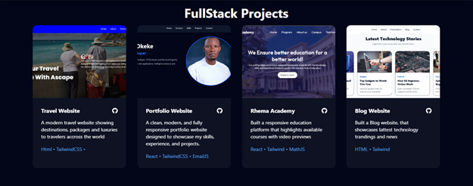
Figure 4.6: Full Stack Projects Section

4.6.1 Overview
The Full Stack Projects section showcases selected software projects using responsive project cards. Each card includes a preview image, title, description, technology stack and GitHub icon.

4.6.2 Section Layout
Projects are displayed in a responsive four-column grid on large screens and adapt automatically to tablet and mobile layouts using Tailwind CSS.

4.6.3 Project 1 – Travel Website
A modern travel website developed using HTML and Tailwind CSS. The application presents travel destinations, packages and tourism experiences through an attractive responsive interface.

4.6.4 Project 2 – Portfolio Website
The developer's personal portfolio website showcasing professional profile, services, projects, skills, education and contact information. Built with React, Tailwind CSS and EmailJS.

4.6.5 Project 3 – Rhema Academy
An educational platform developed with React, Tailwind CSS and MathJS. The website presents courses, institutional information and interactive learning resources.

4.6.6 Project 4 – Blog Website
A responsive technology blog developed using HTML and Tailwind CSS for publishing technology articles, gadgets and software-related news.

4.6.7 Technology Stack
Across these projects the primary technologies include HTML5, CSS3, JavaScript, ReactJS, Tailwind CSS, EmailJS and MathJS, demonstrating proficiency in modern frontend development.

4.6.8 Technical Implementation
Projects employ reusable UI components, responsive layouts, semantic HTML, utility-first Tailwind CSS styling and optimized media assets.

4.6.9 Responsive Behaviour
Cards automatically adjust from four columns on desktop to fewer columns on smaller devices while preserving spacing and readability.

4.6.10 Accessibility & User Experience
Readable typography, high colour contrast, descriptive project summaries and intuitive layouts improve usability.

4.6.11 Future Enhancements
Add live deployment links, project filtering, detailed case studies, backend integrations, authentication and analytics dashboards.

4.6.12 Summary
The Full Stack Projects section demonstrates practical software engineering experience across business, education, blogging and portfolio development.

4.2 Education & Professional Experience

This section presents the academic qualifications and professional career timeline of Franklin Okeke. It demonstrates educational achievements, internships, engineering practice, and AI software development experience. The design uses a clean vertical layout with year labels, job titles, organization names, and concise descriptions.

Screenshot
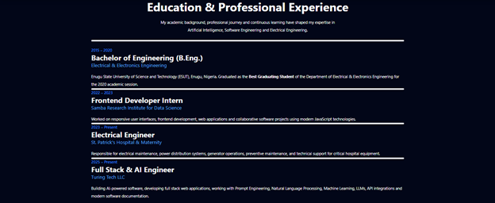

Purpose
- Showcase educational background.
- Present chronological professional experience.
- Demonstrate career growth from engineering to AI and Full Stack Development.
- Build credibility for recruiters and clients.

Displayed Entries
Period | Role | Organization | Highlights
2015–2020 | B.Eng. Electrical & Electronics Engineering | ESUT | Best Graduating Student
2022–2023 | Frontend Developer Intern | Samba Research Institute for Data Science | Responsive UI, JavaScript
2023–Present | Electrical Engineer | St. Patrick's Hospital & Maternity | Maintenance, power systems
2025–Present | Full Stack & AI Engineer | Turing Tech LLC | LLMs, NLP, Prompt Engineering, APIs

UI Components
• Section heading and introduction.
• Chronological experience blocks.
• Year indicators.
• Job title and organization.
• Description of responsibilities and achievements.
• Dark theme with blue accent typography.

Functional Analysis
The section enables visitors to quickly understand the portfolio owner's academic foundation and career progression. It highlights increasing responsibility across Electrical Engineering, Frontend Development, and AI Engineering while emphasizing practical experience.

Design Evaluation
Strengths:
• Clear chronological order.
• Strong visual hierarchy.
• Easy readability.
• Professional appearance.
Suggested improvements:
• Replace divider-line layout with timeline cards.
• Add company logos.
• Include achievement badges or certificates.
• Add links to organizations.

4.3 Certifications & Continuous Learning

This section highlights the continuous professional development of the portfolio owner. Rather than listing formal certificates only, it showcases the major technical domains in which continuous learning and practical experience have been acquired. The card-based layout reinforces specialization across Artificial Intelligence, Full Stack Development, and Electrical Engineering.

Screenshot
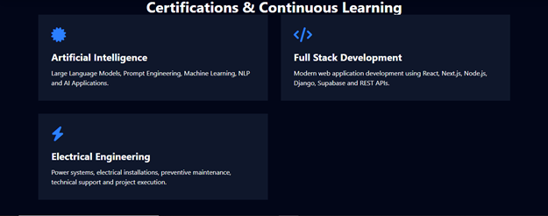

Purpose
• Demonstrate commitment to lifelong learning.
• Highlight key technical specializations.
• Increase professional credibility.
• Showcase multidisciplinary expertise.

Certification Areas
Area | Topics Covered | Technologies | Outcome
Artificial Intelligence | LLMs, Prompt Engineering, Machine Learning, NLP | OpenAI APIs, AI Workflows | AI application development
Full Stack Development | Frontend & Backend Engineering | React, Next.js, Node.js, Django, Supabase, REST APIs | Modern web applications
Electrical Engineering | Power systems, maintenance, installations | Electrical infrastructure | Industrial engineering solutions

User Interface Components
• Section heading
• Three certification cards
• Professional icons
• Bold certification titles
• Short competency descriptions
• Responsive two-column card layout on large screens.

Functional Analysis
The section summarizes the portfolio owner's strongest knowledge domains. Each card provides a concise overview of practical competencies rather than lengthy descriptions, enabling recruiters and clients to identify areas of expertise quickly.

Design Evaluation
Strengths
• Clean card-based presentation.
• Strong visual hierarchy.
• Consistent branding.
• Easy to scan.
Suggested Improvements
• Include certification providers (Google, Microsoft, Coursera, IBM, etc.).
• Add issue dates.
• Include credential IDs where applicable.
• Link each certification to an online verification page.

Conclusion
The Certifications & Continuous Learning section communicates a commitment to continuous professional growth. It complements the Education and Experience section by emphasizing modern technical skills and ongoing learning in AI, software engineering, and electrical engineering.

4.4 Achievements & Recognition

The Achievements & Recognition section showcases major academic, professional, and technical accomplishments. It highlights measurable milestones and demonstrates the portfolio owner's commitment to excellence, innovation, and continuous professional growth. The section combines achievement cards with numerical statistics to reinforce credibility and present accomplishments in a visually engaging manner.

Screenshot
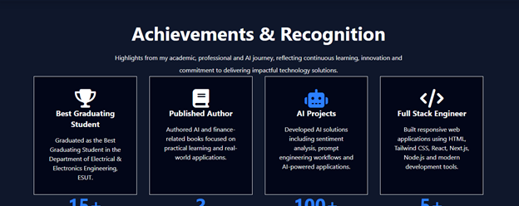

Purpose
• Highlight major career achievements.
• Showcase academic excellence.
• Demonstrate practical AI and Full Stack experience.
• Present quantitative career statistics.
• Increase recruiter and client confidence.

Achievement Cards
Achievement | Description | Business Value | Icon
Best Graduating Student | Graduated as Best Graduating Student in Electrical & Electronics Engineering at ESUT. | Academic excellence and strong engineering foundation. | 🏆
Published Author | Authored books on Artificial Intelligence and Financial Literacy. | Demonstrates research, writing and domain expertise. | 📘
AI Projects | Developed AI solutions including NLP, sentiment analysis and prompt engineering. | Shows practical AI implementation skills. | 🤖
Full Stack Engineer | Built responsive web applications using modern technologies. | Demonstrates software engineering capability. | </>

Performance Metrics
The lower section presents quantitative achievements:
• 15+ Projects Completed
• 2 Published Books
• 100+ AI Prompts Created
• 5+ Technologies Mastered
These statistics provide measurable evidence of productivity and technical competence.

User Interface Components
• Section heading and introduction
• Four achievement cards
• Professional icons
• Responsive grid layout
• Numerical statistics
• Consistent dark theme with blue accents

Functional Analysis
This section serves as a credibility component within the portfolio. Rather than simply listing skills, it presents evidence-based accomplishments that demonstrate academic success, software engineering expertise, AI innovation, and professional growth. The achievement metrics help visitors quickly evaluate the owner's experience and impact.

Design Evaluation
Strengths
• Strong visual hierarchy.
• Easy-to-read card layout.
• Balanced spacing and typography.
• Quantifiable achievements improve trust.

Recommendations
• Add external verification links.
• Include award dates.
• Link published books.
• Make statistics animated.
• Add organization logos where applicable.

Conclusion
The Achievements & Recognition section reinforces the portfolio owner's professional brand by combining academic awards, published work, AI expertise, and measurable career accomplishments into a concise and visually compelling presentation.

4.5 Contact Section
The Contact section enables visitors, recruiters, and potential clients to communicate directly with the portfolio owner. It combines a responsive contact form with essential contact information, providing a simple and professional communication interface.

Screenshot
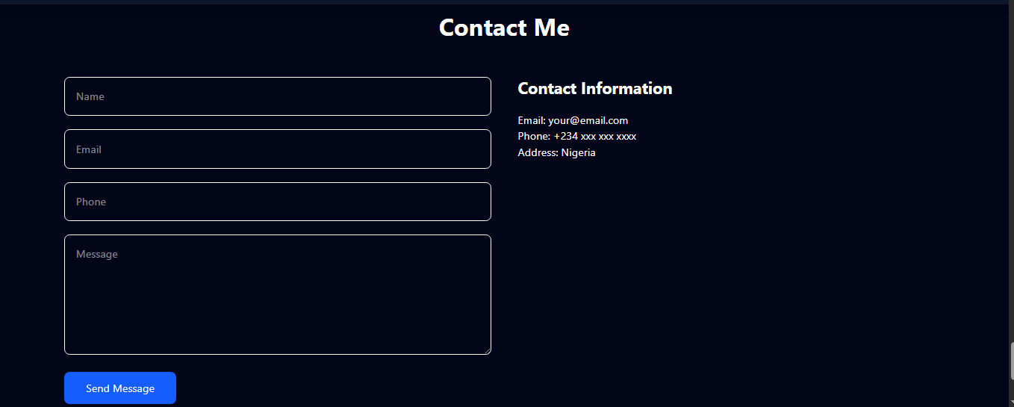

Purpose
• Allow visitors to send enquiries.
• Provide direct contact information.
• Support collaboration and job opportunities.
• Offer a responsive communication interface.

Interface Components
Component | Description | Function
Name Field | Single-line text input | Captures sender name
Email Field | Email input | Captures valid email address
Phone Field | Telephone input | Captures contact number
Message Field | Multi-line text area | Stores enquiry message
Send Button | Submission control | Submits the form
Contact Information | Email, phone, address | Alternative contact methods

Functional Analysis
Users complete the form by entering their name, email, phone number, and message before submitting. The contact information panel provides alternative communication channels. The layout adapts responsively from two columns on larger screens to a single column on mobile devices.

Validation Requirements
• Name should not be empty.
• Email should follow a valid email format.
• Phone number should contain valid digits.
• Message should not be blank.
• Display user-friendly success or error feedback after submission.

Design Analysis
The minimalist dark-theme design matches the rest of the portfolio, maintaining visual consistency. Clear spacing, rounded inputs, and a two-column layout improve readability and usability.

4.6-Footer Section
The Footer section forms the concluding component of the portfolio website. It provides quick navigation links, social media links, contact shortcuts, and copyright information. The footer offers visitors an alternative way to access key pages and communication channels while maintaining a clean, professional appearance consistent with the website's dark theme.

Screenshot


Purpose
• Provide secondary site navigation.
• Offer quick access to social media profiles.
• Display contact shortcuts.
• Present copyright and ownership information.
• Improve usability and accessibility.

Footer Components
Component | Description | Function
Navigation Links | Home, Services, Skills, Projects | Quick access to major sections
Social Links | LinkedIn, GitHub, YouTube | Connect with professional profiles
Contact Links | Email, Phone | Alternative communication methods
Divider | Horizontal line | Separates navigation from copyright
Copyright Notice | © 2026 Franklin Okeke. All Rights Reserved. | Indicates ownership and intellectual property

Functional Analysis
The footer remains accessible at the bottom of every page and acts as a secondary navigation area. Visitors can quickly move to important sections, access external professional profiles, or retrieve contact information without scrolling back to the top of the website.

Design Analysis
The footer adopts the same dark color palette used throughout the portfolio, ensuring visual consistency. The content is organized into three logical groups (navigation, social links, and contact information) with a horizontal divider separating them from the copyright notice. This layout improves readability while maintaining a clean and professional appearance.

Accessibility Considerations
• High color contrast improves readability.
• Simple text links are keyboard accessible.
• Logical grouping improves navigation.
• Footer remains responsive across screen sizes.

Section 5.0: System Architecture
This section describes the overall architecture, major software layers, technology stack and data flow of the portfolio website.

5.1 Architecture Style
The system uses a client-side layered architecture comprising Presentation (HTML), Styling (Tailwind CSS), Interaction (JavaScript), and External Resources (social links, icons, resume).

5.2 Architecture Diagram
User -> Browser -> HTML -> Tailwind CSS + JavaScript -> UI Components (Navbar, Hero, Services, Skills, AI Projects, Full Stack Projects, Education, Certifications, Achievements, Contact, Footer) -> External Resources

5.3 Technology Stack
Layer | Technology | Purpose
Frontend | HTML5 | Structure
Styling | Tailwind CSS | Responsive design
Logic | JavaScript | UI interaction
Icons | Font Awesome | Icons
Hosting | GitHub Pages /Vercel | Deployment

5.4 Data Flow
User request → Browser renders HTML → Tailwind applies styling → JavaScript executes interactions → User accesses projects, downloads CV, or submits contact form.

Section 6.0: Detailed System Design

This section provides a detailed description of every major functional component of the portfolio website, explaining its purpose, design, functionality, technologies used, and user interaction.

6.1 Navigation Bar
Purpose: Provides consistent navigation across the website. Includes logo, navigation links, and Call Me button. Responsive layout ensures usability on desktop and mobile.
Technologies: HTML5, Tailwind CSS, JavaScript
Design Notes: Responsive layout, consistent color palette, reusable components, accessibility and modern UI principles.

6.2 Hero Section
Purpose: Introduces Franklin Okeke with professional profile image, title, summary, social links, and résumé download.
Technologies: HTML5, Tailwind CSS
Design Notes: Responsive layout, consistent color palette, reusable components, accessibility and modern UI principles.

6.3 Services
Purpose: Displays eight service cards describing software engineering, AI, analytics, documentation, deployment, UI/UX and electrical engineering services.
Technologies: Tailwind CSS Cards
Design Notes: Responsive layout, consistent color palette, reusable components, accessibility and modern UI principles.

6.4 Skills & Technical Competence
Purpose: Presents technical skills as badges with achievement counters.
Technologies: HTML, Tailwind CSS
Design Notes: Responsive layout, consistent color palette, reusable components, accessibility and modern UI principles.

6.5 AI Projects
Purpose: Showcases AI portfolio projects using project cards with video previews, descriptions and technology tags.
Technologies: HTML5 Video
Design Notes: Responsive layout, consistent color palette, reusable components, accessibility and modern UI principles.

6.6 Full Stack Projects
Purpose: Displays completed web projects in responsive cards linking to repositories or live demos.
Technologies: Responsive Cards
Design Notes: Responsive layout, consistent color palette, reusable components, accessibility and modern UI principles.

6.7 Education & Professional Experience
Purpose: Summarizes academic qualifications and professional timeline.
Technologies: HTML
Design Notes: Responsive layout, consistent color palette, reusable components, accessibility and modern UI principles.

6.8 Certifications & Continuous Learning
Purpose: Highlights continuous learning areas including AI, Full Stack Development and Electrical Engineering.
Technologies: Cards
Design Notes: Responsive layout, consistent color palette, reusable components, accessibility and modern UI principles.

6.9 Achievements & Recognition
Purpose: Presents awards and measurable accomplishments using statistic cards.
Technologies: Cards
Design Notes: Responsive layout, consistent color palette, reusable components, accessibility and modern UI principles.

6.10 Contact
Purpose: Contains contact form and personal contact information.
Technologies: HTML Form
Design Notes: Responsive layout, consistent color palette, reusable components, accessibility and modern UI principles.

6.11 Footer
Purpose: Provides quick links, copyright information and social navigation.
Technologies: Footer
Design Notes: Responsive layout, consistent color palette, reusable components, accessibility and modern UI principles.

Section 7.0: User Interface (UI) & User Experience (UX) Design

7.1 Overview
The portfolio emphasizes a modern, responsive, dark-themed interface with blue accent colors. The UX is designed for fast navigation, readability, clear calls-to-action, and logical grouping of information.

Complete Interface Overview
Shows the complete landing page and information hierarchy.
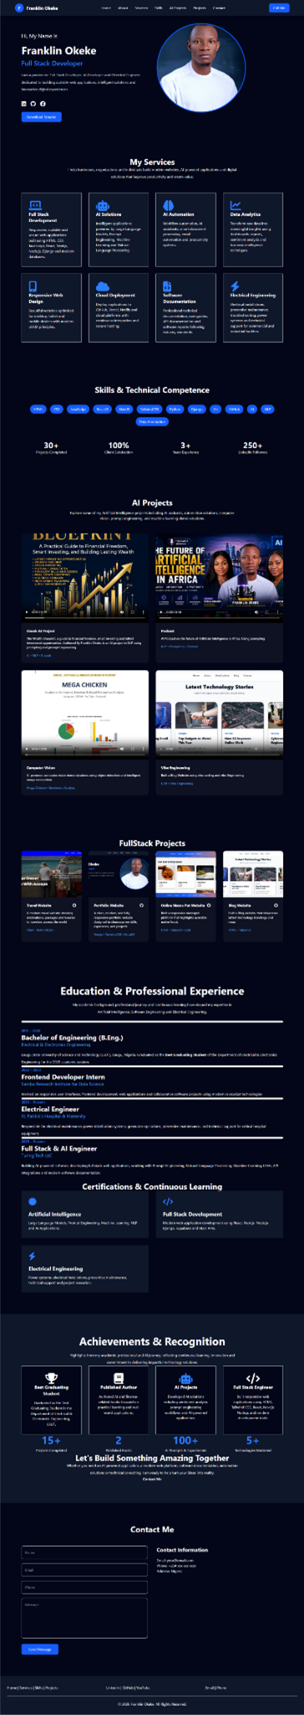

Navigation Bar
Sticky navigation with direct links and Call Me CTA.

Hero Section
Personal introduction, profile image, social icons and resume download.
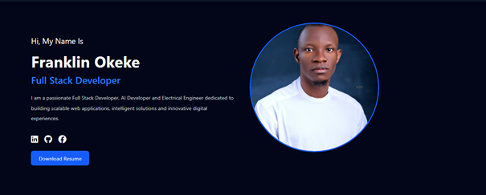

Services
Grid-card layout presenting eight services.
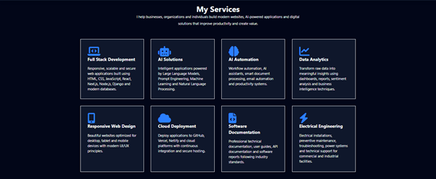

Skills
Technology badges and achievement counters.
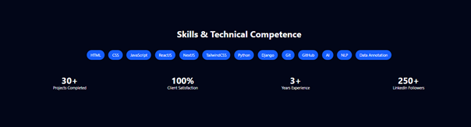

AI Projects
Interactive project showcase with video previews.
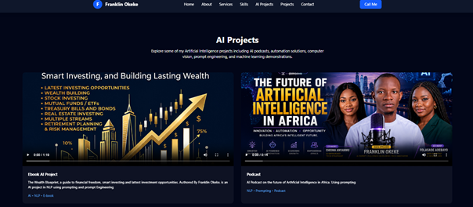

Full Stack Projects
Portfolio cards highlighting completed development projects.
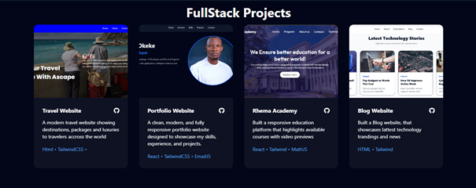

11.2 UI Design Principles
• Consistent dark theme with blue accent color.
• Clear visual hierarchy using large headings and spacing.
• Card-based layout for easy scanning.
• Responsive grid adapting to desktop, tablet and mobile.
• Rounded buttons and images for modern aesthetics.
• Consistent typography and iconography.

11.3 UX Design Principles
Navigation is intuitive through the fixed navbar. Users can quickly access services, skills, AI projects, portfolio projects and contact information. Interactive buttons, project previews and contact form improve engagement while responsive design ensures usability across devices.

Chapter 8.0: Conclusion

8.1 Conclusion
This portfolio website project successfully achieved its primary objective of creating a modern, responsive, and professional online platform for showcasing the academic background, technical skills, professional experience, AI projects, software development projects, certifications, achievements, and contact information of Franklin Okeke. The system was designed with a user-centered approach, emphasizing simplicity, accessibility, performance, and visual consistency.

8.2 Summary of the Project
The website integrates multiple sections into a single-page portfolio with smooth navigation. It demonstrates competencies in Full Stack Development, Artificial Intelligence, Data Analytics, Prompt Engineering, and Electrical Engineering while providing visitors with an easy way to explore projects and establish contact.

8.3 Objectives Achieved
· Developed a responsive and mobile-friendly portfolio website.
· Presented professional services and technical competencies clearly.
· Showcased AI and Full Stack projects using rich media.
· Highlighted education, work experience, certifications, and achievements.
· Provided a functional contact section for communication.
· Applied modern UI/UX principles for usability and accessibility.

8.4 Technologies Utilized
HTML5, Tailwind CSS, JavaScript, react concepts, responsive web design principles, Git/GitHub, modern UI/UX practices, and multimedia integration formed the technical foundation of the system.

8.5 Overall Evaluation
The completed portfolio provides a strong professional identity and serves as a central platform for demonstrating technical capability to employers, clients, collaborators, and academic reviewers. Its modular architecture allows future expansion with backend services, databases, authentication, analytics, and AI-powered features without major redesign.

8.6 Closing Statement
This project demonstrates the practical application of software engineering principles, modern web development technologies, and user interface design in producing a scalable digital portfolio. The documentation captures the design, implementation, architecture, and evaluation of the system, providing a comprehensive reference for future maintenance and enhancement.

